GROUP THREE

DEVICE WRITE UP

Omar Vallejo

Tiffany Watson

Darian Thomas

Rachael Strehlow

Ricky Rivera

**EDGE DEVICE 1: Ricky Rivera - Timer**

1. Descriptions of each edge device and what they do.
   1. Timer Edge Device: Uses a rotary encoder to take input from the user. Turn the rotary encoder to create a timer, the farther you turn it then the longer the timer is. After a timer is created it counts down. Every second that goes by an LED blinks. Once the timer hits 0 a buzzer is sounded to inform the user the timer has stopped and then the database is updated.
2. Drawings of the circuits for each edge device. These should be done on a computer.

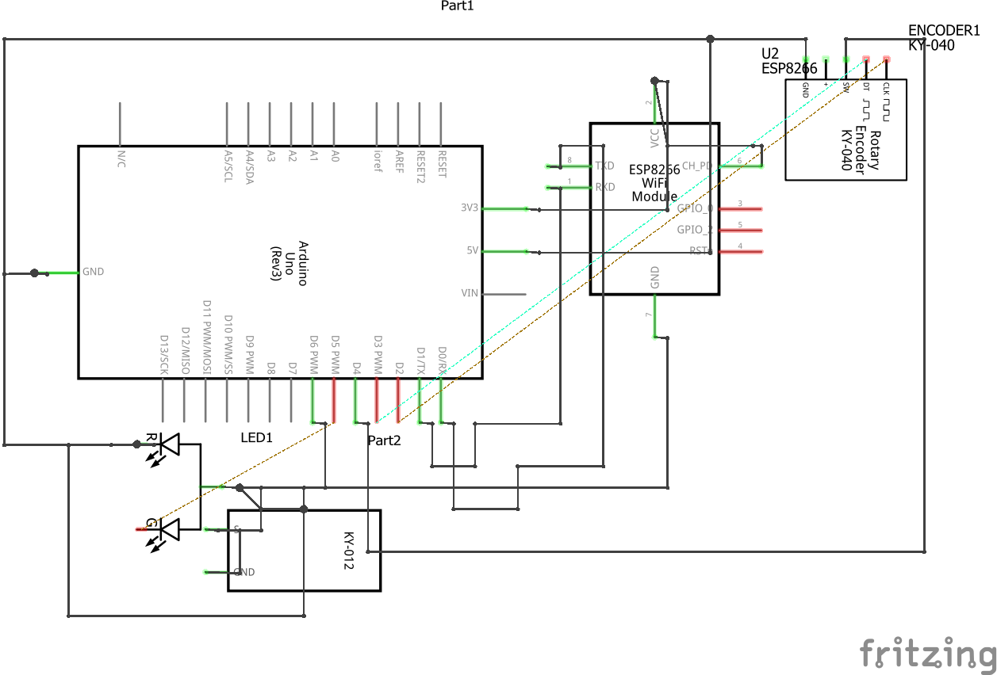

1. Drawings of the arduino configuration of each edge device (use fritzing.org)

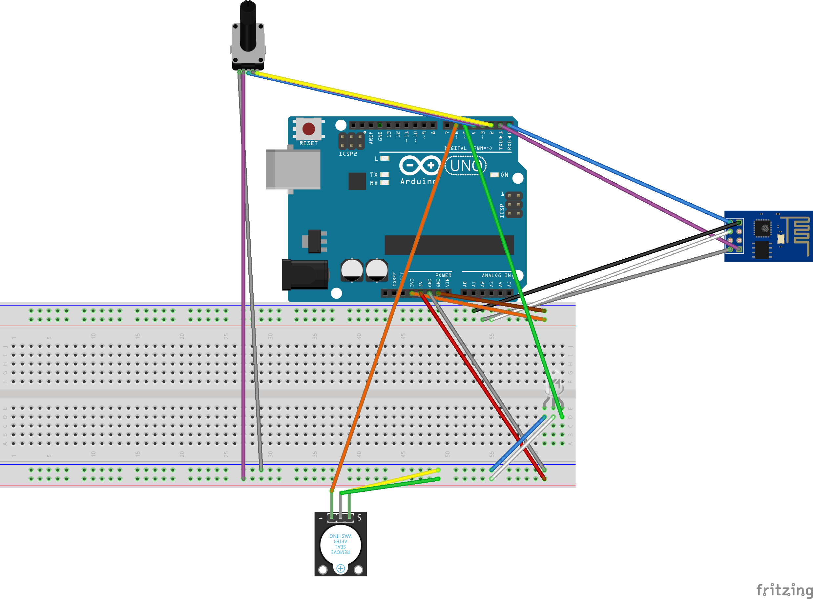

1. A copy of the database table structure.

Timer_Table

|  |  |  |
| --- | --- | --- |
| **Column Name** | **Data Type** | **Description** |
| ROW_ID | Integer | This is the primary key, it cannot be null and should auto increment by 1 each time a row is entered |
| DEVICE_ID | Varchar of 25 characters | This is a unique device id |
| TIMERS_CREATED | Integer | How many timers have been created |
| TOTAL_TIME | Float | All the times of the timers added together. |
| AVG_TIME | Float | Average time of all of the timers |

1. A sample of how to interact with the gateway program, please include screenshots

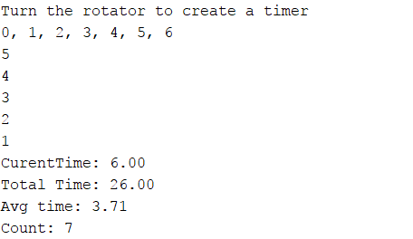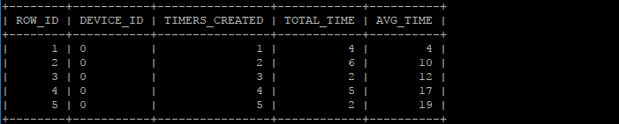

* Tell the user to turn the rotator to create a timer
* Values are printed to the screen as the user turns the rotator
* Program counts down
* Once the program is done counting down it shows the analytics
* Information is then sent to the database table

**EDGE Device 2: Omar Vallejo - Fire Detector**

1. Descriptions of each edge device and what they do.

My Fire Detecting IoT device is designed to alert if there is a live fire. The device uses a flame sensor to read the values of a fire when there is one present. If there is a fire detected, the device will set off an LED alarm to identify of the threat.

1. Drawings of the circuits for each edge device. These should be done on a computer.

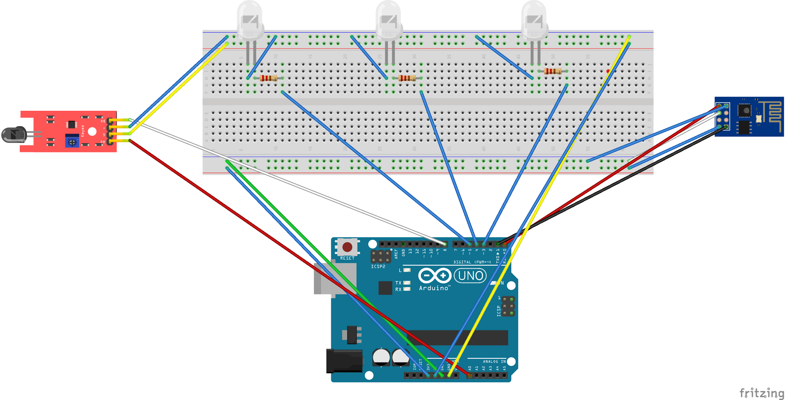

1. Drawings of the arduino configuration of each edge device (use fritzing.org)

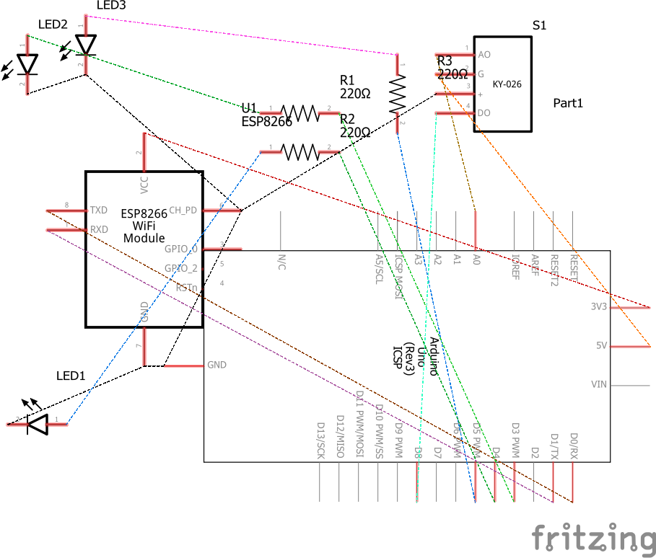

1. A copy of the database table structure.

Flame_Table

|  |  |  |
| --- | --- | --- |
| **Column_Name** | **Data Type** | **Description** |
| Row_ID | Int | This is the primary key, it cannot be null and should auto increment by 1 each time a row is entered |
| Device_ID | Varchart 25 | This is a unique device id. |
| Fire_Detection | Varchart 25 | Identifies if a fire is detected or not. |
| Time_Lit | Int | Counts how long the fire was going for. |

1. A sample of how to interact with the gateway program, please include screenshots

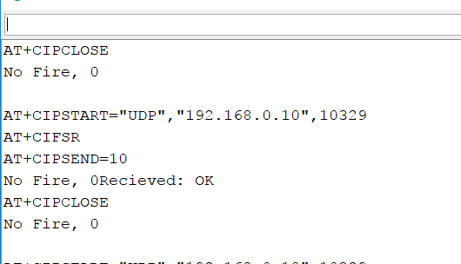

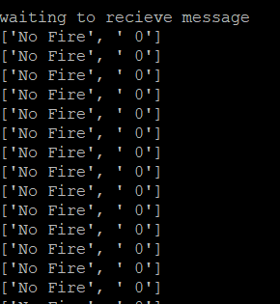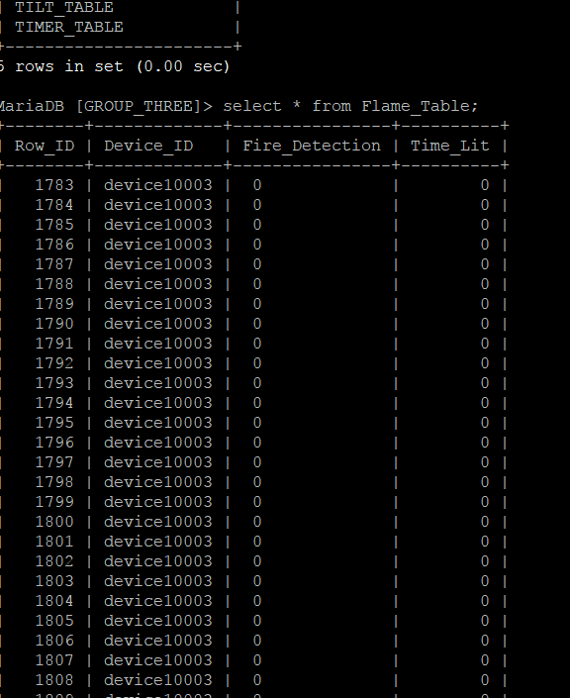

-User must hold up the flame sensor away from wiring

-To detect a flame, hold near an open flame

-If not flame is detected, it will read back no fire and will continue to search for fire.

**EDGE DEVICE: Tiffany Watson - Light Sensor**

Light Source Edge Device: A light that turns on by sound using a big sound sensor, with a knob by twisting the knob or from a photoresistor when it is dark. The big sound sensor turns the light on high. The knob works as a dimmer switch to adjust the brightness of the light. The photoresistor turns on a dim light as a nightlight when dark.

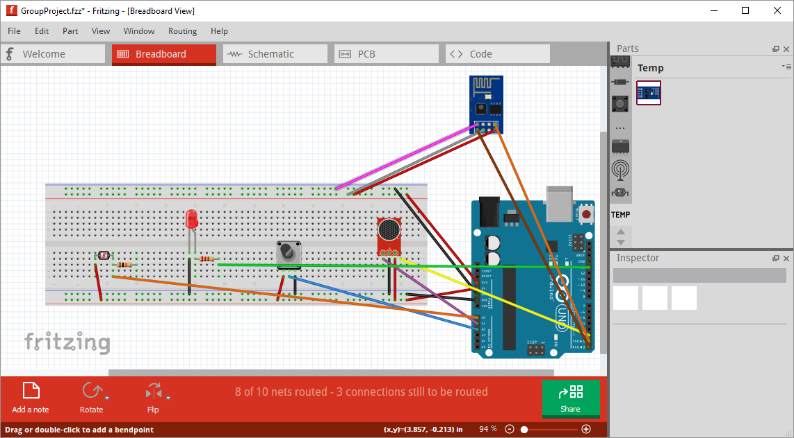

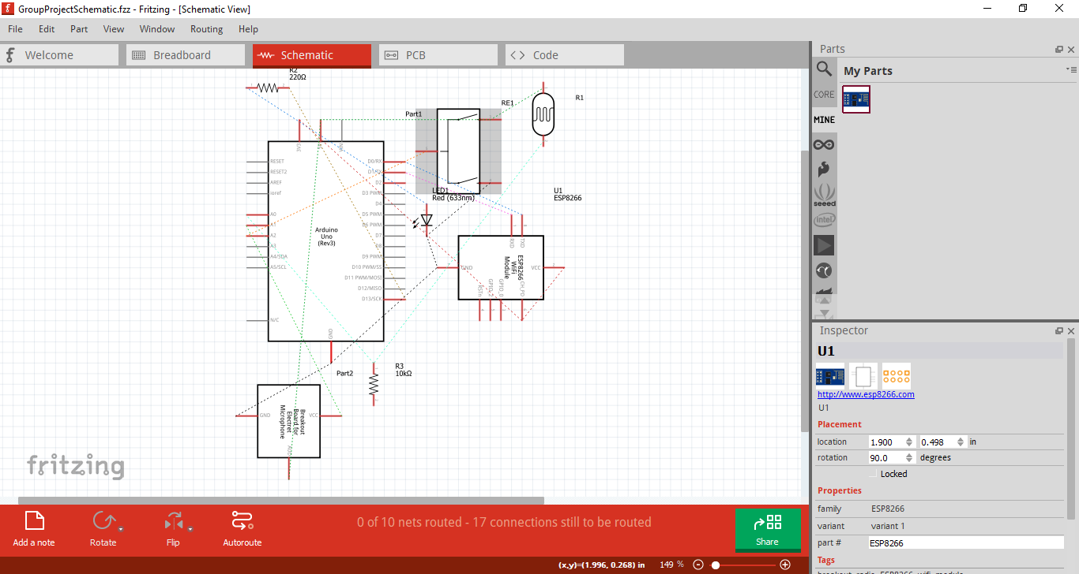

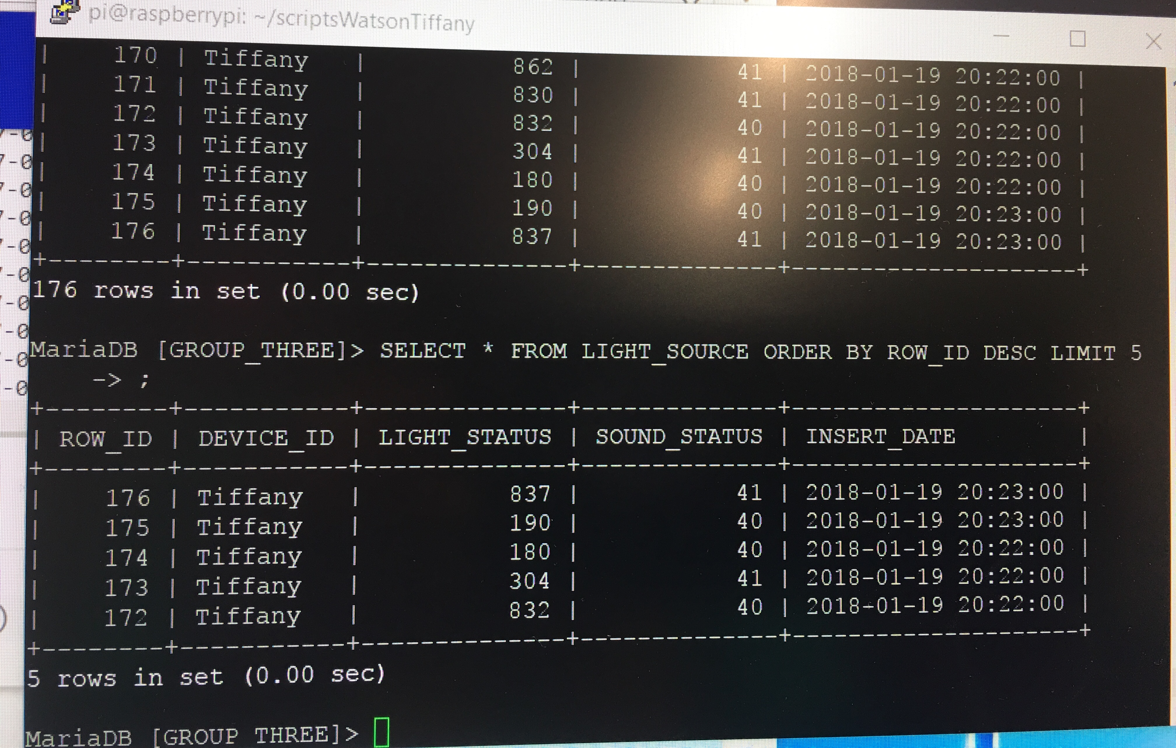

LIGHT_SOURCE

|  |  |  |
| --- | --- | --- |
| **Column Name** | **Data Type** | **Description** |
| ROW_ID | int(11) | This is the primary key, it cannot be null and should auto increment by 1 each time a row is entered |
| DEVICE_ID | varchar(25) | This is a unique device id |
| LIGHT_STATUS | int(11) | Records how bright/dark it is in the room |
| SOUND_STATUS | int(11) | Records the noise level in the room |
| INSERT_DATE | timestamp | Timestamp of the data |

**EDGE DEVICE: Rachael Strehlow - Tilt Switch**

1. Descriptions of each edge device and what they do.

Tilt edge device: My device uses a tilt switch and the two-color LED, when the switch it tilted it would activate the LED. This device would be either on the refrigerator or oven door to fit into our smart kitchen theme.

1. Drawings of the circuits for each edge device. These should be done on a computer.

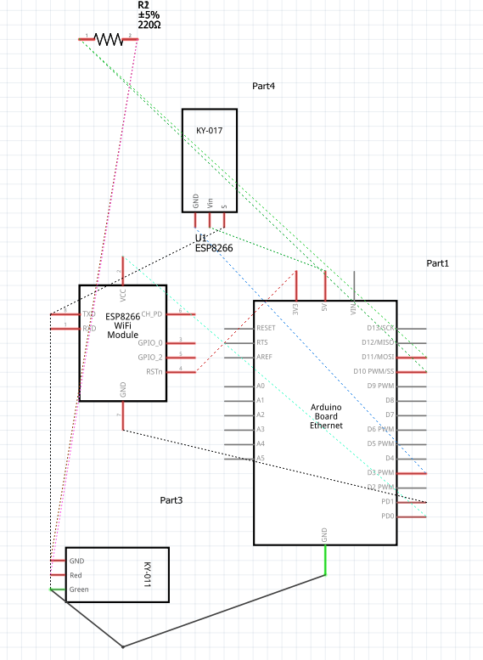

1. Drawings of the arduino configuration of each edge device (use fritzing.org)

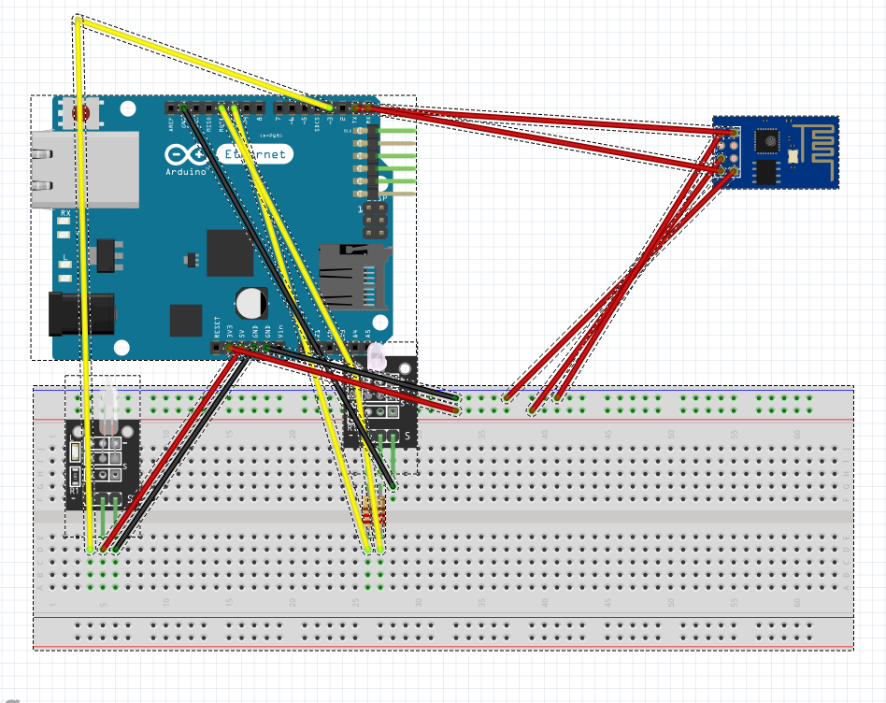

1. A copy of the database table structure.

|  |  |  |
| --- | --- | --- |
| **Column_Name** | **Data Type** | **Description** |
| ROW_ID | Int | This is the primary key, it cannot be null and should auto increment by 1 each time a row is entered. |
| DEVICE_ID | Varchart 25 | This is a unique device id. |
| TILT_READ | int | Reading of the mercury in the tilt switch. |
| LIGHT_OUTPUT | Int | Tells whether the light is on or off. 1:on, 2:off. |

1. A sample of how to interact with the gateway program, please include screenshots

The user would tilt the arduino to represent a door being opened. The gateway will show the mercury level from the tilt switch and whether or not the light in on or off shown by either a 1 or 2.

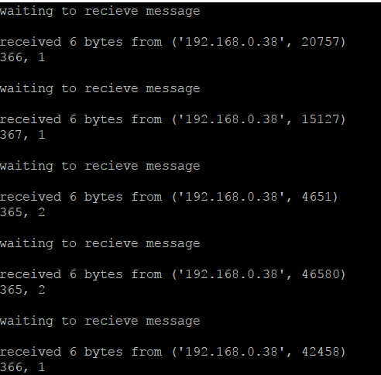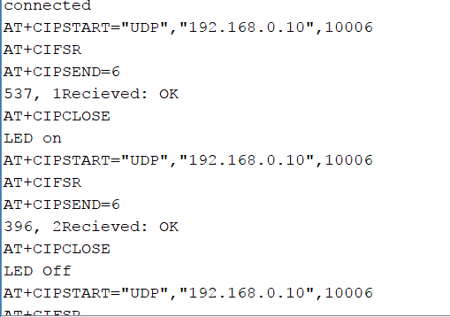

**Edge Device - Darian Thomas**

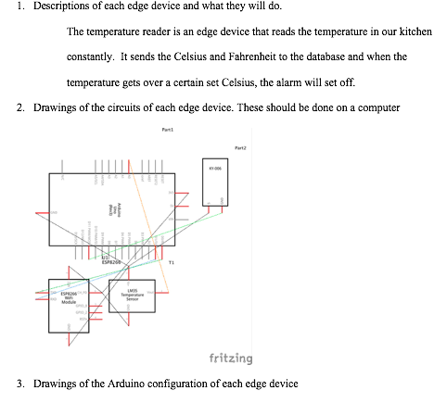

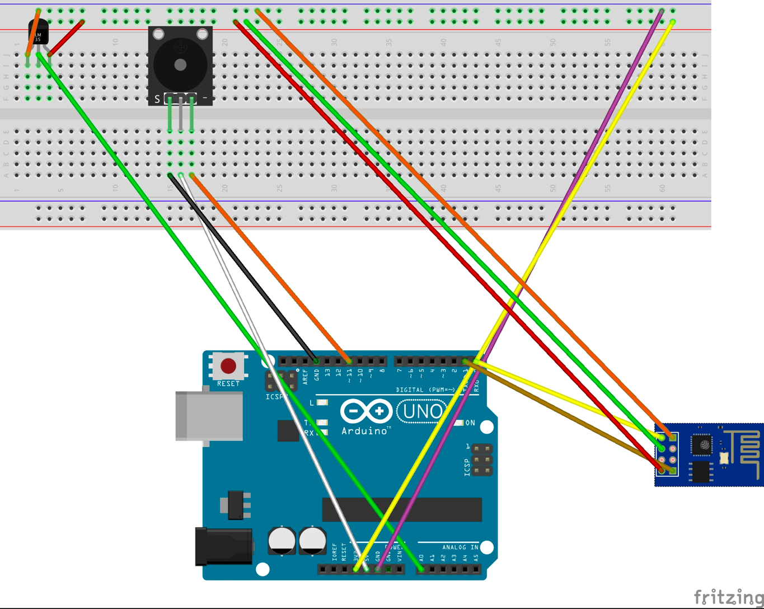

4. A copy of the database table structure

|  |  |  |
| --- | --- | --- |
| Column Name | Data Type | Description |
| ROW_ID | Integer | This is the primary key, it cannot be null and should auto increment by 1 each time a row is entered. |
| DEVICE_ID | Varchar 25 char | This is a unique device id. |
| Temp_ACT | Float | This shows the temperature in celcius and farenheit |
| Temp_Time | DATE | This shows the recorded time when the temperature exceeded the threshold |

5. A sample of how to interact with the gateway program, please include screenshots

